# **SMART GREENHOUSE/GARDENER**

For my final year project, I plan to develop a smart garden/greenhouse system which allows users to garden and monitor plants/crops in the best way possible. The idea of this project is to create an affordable automated/connected Indoor garden or greenhouse that can modernize and re vamp gardening for the better. I always had an interest in gardening and thought this would be a perfect project idea as I find it interesting and feel it will be very.

One of the primary objectives of this project was to be able to maintain the well-being of a garden using the power of the Internet of Things (IoT). I plan to integrate sensors such as soil moisture, temperature and humidity sensors which help monitor the real-life status of the plants. I want to store the data produced by these sensors on a web server or application and allow the user to judge and study the information provided and then be able to take the appropriate action required for maximum growth of their crops.

As mentioned above I plan to develop some sort of application which is compatible to this project. I want the user to be allowed to carry out actions such as plant watering and feeding directly from their PC or smartphone with the touch of a button. The application may also be used to store data such as the soil moisture, temperature and humidity of the garden or greenhouse. A fan system may also be installed in the project to allow for ventilation inside the greenhouse this could also be controlled by the android application.

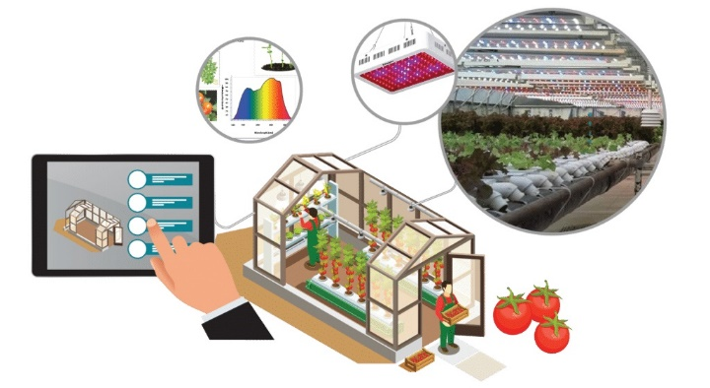The hardware used in this project may change as the year goes on however as of now, I plan on using Raspberry pi as I think with the sheer amount, I want this project to do it is the best option. As mentioned earlier I also plan on integrating sensors. A temperature sensor such as the DHT11 will be a good option for this, I will also use a soil moisture sensor to know the moisture of the soil which may be connected to an automatic watering system. Fans, Water pumps, and even some lighting system may also be installed in the project. Bluetooth or WIFI will be used to allow control of these systems via PC or smartphone.

I am looking forward to getting started with this project as I feel there is endless possibilities and if it all goes to plan, it will be a very successful project.

